Official Premium List


THE BRITISH COLUMBIA LABRADOR RETRIEVER CLUB (1995) SOCIETY

CKC LICENSED WC/WCI/WCX TESTS

For All Retrievers, Irish Water Spaniels, Standard Poodles, Airedale Terriers & Barbets

Flat-Coated Retriever Society of Canada Booster
The FCRSC will be offering prizes for all passing Flat-coated Retrievers.

Sunday, July 17, 2016 – Deroche, B.C.

Running Schedule
WC – 8:30 am
WCI/X – 8:30 am – order start at Judge’s discretion

Judges & Stakes

Stephen Yezerinac – 28-19180 65th Ave. Surrey, BC V4N 6M5 – WC
Barry Kolodychuk – 8071 Atchelitz Rd. Chilliwack, BC V2R 4H4 – WC
Sheila Kenny – 4546 Marsden Rd. Courtenay, BC V9N 9M7 – WCI/X
Judy Teskey, 13351 Keene Rd. Ladysmith, BC V9G 1G2 – WCI/X

CKC Executive Director
Lance Novak, 200 Ronson Drive, Suite 400, Etobicoke, ON M9W 5Z9

CKC Provincial Director (BC Interior & Yukon)
Russel Fletcher, 709 Stone Rd., Louis Creek, BC V0E 2EO (250) 672-5856

CKC WC Director (BC Interior & Yukon)
Cheryl Young, RR 3, 35171 Youngston Rd., Mission, BC V2V 4J1 (604) 820-8765

LRCC Officers

President: Judy Simonett Vice President: Lisa Terrance
Secretary: Nancy Kotani Treasurer: Nancy Ingham

WC Test Committee

Chairperson & Test Secretary: Robin Traynor
Committee: Members of the BCLRC

Entries close on Friday, July 8, 2016 at 8:00 p.m.
These events held under the rules of The Canadian Kennel Club

FYI

- Bitches in season will not be eligible to compete and are not allowed on the test grounds.
- Ducks, pheasants, chukkars and/or pigeons will be used.
- Rosettes will be awarded to all dogs who pass the test.
- A draw for running order will be held at the home of the Test Secretary.
- It shall be the duty and obligation of the test-giving club to see that a judge, club official, volunteer, or any participant at an event held under these rules is not subject to indignities of any kind. The Working Certificate Test Committee Chair shall promptly report to the CKC any infringement of this regulation, and the Discipline Committee shall have the authority to take such action as it deems fit on receipt of a report indicating that this has occurred.
- There will be a lunch available for a minimum fee.
- By attending this test, competitors and spectators acknowledge that The British Columbia Labrador Retriever Club (1995) Society, test officials and landowners involved do not accept liability for any loss, damage or injury incurred by exhibitors, dogs or spectators.

Entry

Listing fee: A $8.82 (inc GST) listing fee as established by the CKC must accompany the entry of a dog for which no valid CKC individual registration, an ERN or PEN is shown on the entry form.
Payment: Please make all cheques, money orders or drafts payable in Canadian funds to the British Columbia Labrador Retriever Club (1995) Society (abbreviated: “B.C.L.R.C.”). US funds must be in the form of a Canadian money order (US funds at par).

ENTRY FEES: WC - $50.00 WCI - $55.00 WCX - $60.00

PLEASE NOTE: THE NON MEMBER PARTICIPATION FEE WAS EFFECTIVE JANUARY 1, 2011
AN ANNUAL NON-MEMBER PARTICIPATION FEE for awards and titles will be charged to a CANADIAN
NON-MEMBER OF CKC. The fee will match the ERN fee.
In order to protect the awards/titles earned, the non-member will have a choice either to become a CKC member or to pay the non-member participation fee.
Failure to comply within 30 days of notification will cause all awards and titles to be cancelled.
These fees apply only to dogs wholly owned by non-CKC members and are not applicable to CKC members.

Please send or deliver, by Friday July 8, 2016, at 8:00 p.m., one entry form per dog with applicable fees to:

Robin Traynor Phone: (250) 296-3698
PO Box 435 Email: traynor@thelakebc.ca
150 Mile House, B.C.
V0K 2G0
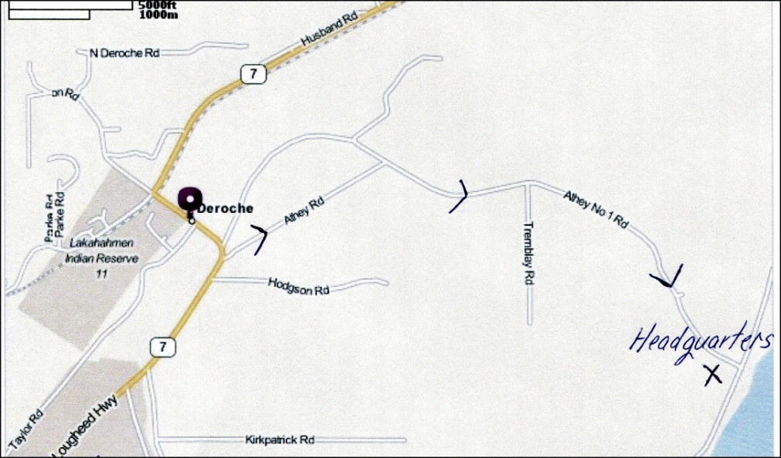

Accommodation – Mission Inn Motel – 34551 Lougheed Hwy, Mission, B.C. 604-826-2023


Official Canadian Kennel Club Entry Form

British Columbia Labrador Retriever Club (1995) Society

Entry Fee $ ____________ Listing Fee $ ____________ Total $ ____________

Breed |  | Call Name |  | Sex
Test Entered  ◻ WC ◻ WCI ◻ WCX |  | Date of Test
Registered Name of Dog

◻ CKC ◻ ERN ◻ Listed |  | Enter Number Here
Place of Birth  ◻ Canada ◻ Elsewhere |  | Date of Birth (M/D/Y)
Breeder(s)

Sire

Dam

Registered Owner(s)

Owner's Address

City | Province |  | Postal Code
Name of Handler

Handler's Address

City | Province |  | Postal Code

I certify that I am the registered owner(s) of the dog or that I am the authorized agent of the owner(s) whose names(s) I have entered above and accept full responsibility for all statements made in this entry. In consideration of the acceptance of this entry, I (we) agree to be bound by the rules and regulations of The Canadian Kennel Club and by any additional rules and regulations appearing in the premium list.

Signature of Owner or Agent: ____________________________________________________________

Telephone Number______________________________________________________________________

Email_________________________________________________________________________________

Official Canadian Kennel Club Entry Form

British Columbia Labrador Retriever Club (1995) Society

Entry Fee $ ____________ Listing Fee $ ____________ Total $ ____________

Breed |  | Call Name |  | Sex
Test Entered  ◻ WC ◻ WCI ◻ WCX |  | Date of Test
Registered Name of Dog

◻ CKC ◻ ERN ◻ Listed |  | Enter Number Here
Place of Birth  ◻ Canada ◻ Elsewhere |  | Date of Birth (M/D/Y)
Breeder(s)

Sire

Dam

Registered Owner(s)

Owner's Address

City | Province |  | Postal Code
Name of Handler

Handler's Address

City | Province |  | Postal Code

I certify that I am the registered owner(s) of the dog or that I am the authorized agent of the owner(s) whose names(s) I have entered above and accept full responsibility for all statements made in this entry. In consideration of the acceptance of this entry, I (we) agree to be bound by the rules and regulations of The Canadian Kennel Club and by any additional rules and regulations appearing in the premium list.

Signature of Owner or Agent: ____________________________________________________________

Telephone Number______________________________________________________________________

Email_________________________________________________________________________________

