 | CKC AGILITY TRIAL  Official Premium List | 
Whippet Club of BC
Is hosting FOUR

All Breed CKC Agility Trials
Permission has been granted by the Canadian Kennel Club for holding this event under
Canadian Kennel Club Rules

Events offered
March 29, 2014 #140754: 1 round of STANDARD, 1 round of Points and Distance (PAD)
#140755 2 rounds of Jumpers With Weaves
March 30, 2014 #140756 2 rounds of STANDARD
#140757 2 rounds of STEEPLECHASE and 1 round of Jumpers With Weaves

March 29 and 30, 2014

To be held under cover at the Kelowna Dog Sport Centre

3345 Bulman Road, Kelowna BC
Ring Size 65 X 140 Feet, Surface is packed dirt

Judges:
Saturday: GABRIELE L HUTTON 26489 29TH AVE, ALDERGROVE BC, V4W 3A9
Sunday: CASE H.J. LAAN 21133 GLENWOOD AVE, MAPLE RIDGE BC, V2X 8L1

Whippet Club of BC Club Officers:
President: Adele McNiven
Vice President: Fiona Hart
Secretary Carole Adley
Treasurer: Heather Ivanitz
Trial Committee:
Event Superintendent: Adele McNiven
Trial Secretary: to whom all entries must be sent: Heather Ivanitz, 970 Ackerman Ct., Kelowna BC
Committee: Members of the Whippet Club of BC
Complaints Committee: As set forth in the CKC Rule Book
Official Veterinarian: Fairfield Animal Hospital, 250 860 6550
Canadian Kennel Club Address: The Canadian Kennel Club, 200 Ronson Drive,
Suite 400 Etobicoke, Ontario,M9W 5Z9, (416) 675-5511
C.K.C. Director for BC Interior & Yukon: Russell Fletcher, diplomat@telus.net

Entry Fee structure: All Entry Fees include CKC fees of $4.50 5%GST.
Pre entries – prior to closing date;
Each DAY, each dog, first event = $25.00,
Same DAY, same dog, second event = $20.00
Same DAY additional entries = $15.00
Entry Fee, Package price, same dog (all 9 events) $142.57 (22.43 discount on 9 events)
Post entries – after closing date and before courses are posted $25.00 per event.
Listing fees (see CKC regulations below, to determine if you are required to pay this fee)
Pre entries Close– March 18 2014. Please do not send an entry that requires our trial secretary to travel to the post office to sign for receipt. .

POTENTIAL ADDITIONAL FEES: CKC now requires a non member participation fee of $57.60 plus GST for any titles earned. These fees apply only to CANADIAN dogs wholly owned by non-CKC members and are not applicable to CKC members. CKC membership forms are available at http://www.ckc.ca/en/Default.aspx?tabid=438 see page 5 for more details regarding this item.

Cheques or Money order payment only. Sorry, WCOBC can NOT accept credit card or online entries. NO entry will be accepted without payment in full. Tendering of a N.S.F. cheque in payment of entry fees is considered non-payment of entry fees and is an offense punishable by disciplinary action and cancellation of awards. All N.S.F. cheques will be assessed a $25.00 service charge.
NOTE some new regulations!

CLASSES: There now are 4 classes - Standard, Jumpers With Weaves, and the new two classes Points and Distance, and Steeplechase.

DIVISISONS: There are 3 divisions – Regular, Selected, and Veteran. A dog may enter classes in any division but may not move back and forth between divisions.
Regular division is for all dogs of any breed and any level and any jump height.
Selected division is for dogs that need more time or should not jump the regular jump heights. They run the same course as Regular dogs but jump one height lower and receive 10% more time than Regular division dogs. Starting January 1 2014, a dog entered in Selected may NOT go back to the Regular division. Dogs retain titles and qualifying scores accumulated in the regular division. They are NOT required to move to Novice when moving laterally to Selected.
Veteran division is for dogs 7 years or older. They jump up to 2 jump heights lower and receive 10% more time than regular division dogs. Dogs cannot revert back to Regular or Selected divisions

LEVELS: There are 4 levels in Standard, JWW, and PAD. Novice, Intermediate, Excellent, and Master Excellent. See your rule book for definitions of requirements in each level.
Novice: A dog must be started at the Novice Level for each Class: Standard, Jumpers with Weaves, and PAD. A Selected or Veteran dog may start at the level it had attained in other divisions..
Intermediate: Is open to dogs that have acquired the Agility Novice title, and to those dogs which have acquired the Agility Intermediate title but have not yet acquired a qualifying score towards the Agility Excellent Title.
Excellent: is for dogs that have acquired the Agility Intermediate title, but have not yet earned the Agility Excellent title.
Master Excellent: is for dogs that have acquired the Agility Excellent title or the Agility Master Excellent title.

NOTES: New rules!
1 A and B levels have been eliminated in all classes.
2. There are NO levels in Steeplechase. All dogs run the same course

Equipment and course familiarization:
- Upon previous arrangement, There will be equipment familiarization on Saturday morning for Novice dogs only and on Sunday morning for Novice dogs entered in trials 3 and 4 only.
- A warm – up area with a single practice jump will be provided for dogs entered in the trials.
- Handlers in all classes are permitted to walk the course, without a dog, prior to the start of the class. Only those entered in a class are permitted to walk the course.

Height Divisions – owners are responsible for entering the correct height divisions. The judge may require any dog to be measured.
Dog height at withers | Regular  Jump Heights | Selected Jump Heights | Veteran Jump Heights
10 inches and under | 8 inches | 4 inches | 4 inches
14 inches and under | 12 inches | 8 inches | 8 or 4 inches
18 inches and under | 16 inches | 12 inches | 12 or 8 inches
22 inches and under | 20 inches | 16 inches | 16 or 12 inches
22 inches and over | 24 inches | 20 inches | 20 or 16 inches
Selected and Veteran course times:
10% will be added to the standard times.

All courses have clearly designated start and finish lines with all obstacles/jumps clearly and sequentially numbered. The course layout for each class will be posted in an easily accessible area at least ½ hour before the start of the class.

NOTE: SAME DAY MOVE UPS WILL BE ALLOWED. A dog that has received 3 qualifying scores from at least 2 different judges, may be transferred to the next level provided that request is received at least one hour prior to the commencement of the trial. See event secretary for official form.

Show Catalogues and a timetable will be emailed to all exhibitors after closing date.

List of Awards and Prizes:
- Ribbons will be provided for 1st – 4th in each class and jump height.
- Qualifying ribbons will be awarded for all dogs receiving a qualifying score in each agility trial.
A Qualifying score is 85 points or more out of a possible 100 points, with no non-qualifying deductions except Master Excellent where a perfect run is required.
- This is a qualifying trial for whippets gathering credits toward the 2014 Versatility Whippet of the Year award. .
- For more details on this award contact Adele at wcobc@shaw.ca
- Prize for High score whippet in trial 1, trial 2, trial 3, and trial 4.

NOTE: The current Rule book is dated January 2014. and is available on the CKC website at www.ckc.ca/ It is the responsibility of the exhibitor to be familiar with the rules pertaining to the event in which they are competing.

Trial precincts:
The precincts of the trial are all areas reserved for the sole use of the WCOBC. Only Dogs entered in official classes are permitted within the precincts of the trial.

Agility Rules and Regulations: It shall be the duty and obligation of the trial giving club to see that a judge, club official, volunteer, or any participant at an event held under these rules, is not subject to indignities of any kind. The Agility Trial Committee Chair shall promptly report to the CKC any infringement of this regulation, and the Discipline Committee shall have the authority to take such action as it deems fit on receipt of a report indicating that this has occurred

Withdrawal of entries:
Anyone wishing to withdraw an entry prior to the closing date MUST notify the trial secretary. After closing date only partial refunds may be provided.

Foreign Exhibitors
Entry Payment: Please note that fees are due and payable in Canadian dollars.
Due to consistently fluctuating currency rates, discounted cheques will not be accepted. Personal cheques will be accepted; however, they are to be payable in Canadian Funds. If you send a cheque in US funds, it must be made out for the full amount of the entry and no exchange will be refunded to the exhibitor. Please do not mark cheque, “payable in Canadian Funds” or “at par”. They will not be cleared by the banks. To simplify the process, we urge that you purchase banks drafts for money orders payable in Canadian funds. Your understanding and cooperation is appreciated. Thank you.

General Information:
1. Bitches in Season are not permitted to compete. Entry fees will be refunded when a bitch comes into season after their entry has been submitted to the Trial Secretary, when a Veterinarian's certificate, certifying the bitch was in season within the 10 day period preceding the trial.
2. Judging schedules, directions to site and receipts will be sent by email to exhibitors after the closing date.
4. Before each trial the judges will provide a course design which will be posted before judging begins

The owner of a dog entered in this show is entirely responsible for any errors in the entering of the dog, regardless of how, or by whom the entry was made. Please check your confirmations for accuracy.

No Concession on Site
Tim Hortons, Subway, and various other restaurants are available within 2 KM.

Veterinarian
Fairfield Animal Hospital -- Emergency Services 24 -7. call 250 860 6550.

Dog friendly Hotels and Accommodations
Limited DRY Camping permitted on site. $10 per day. Email Adele at wcobc@shaw.ca
Billeting may be available upon request. Email Adele wcobc@shaw.ca
HOTELS / MOTELS: All accommodations listed are approximately 15 minutes from trial site.
Please ask about dogs in the room. We have checked with these hotels but there are others who may take dogs.
Sandman (250) 860-6409 Hwy 97 across from Orchard Park, $129.75 Dog fee waived.
Town and Country Inn. 860 7121 Dogs welcome. Approx $90. Indoor pool and dog walk area.
Days Inn, Hwy 97 2649 Highway 97 N, Kelowna, BC, V1X4J6, TOLL FREE! 866-460-7456
Howard Johnson 2639 97 Hwy N, Kelowna, BC V1X4J6 Canada 1-855-290-2678

.
Directions to Site
Kelowna Dog Sport Centre

From the North: at Highway 97, immediately after the overpass, turn East (left) onto Hereron Road. Turn North (Left) almost right away onto Bulman Road. Watch for the Kelowna Dog Sport Centre sign on the right. THIS IS A TURF FARM! Drive down to the red barn and park on the North Side. DO NOT ALLOW YOUR DOG TO MAKE ANY CONTACT WITH THE TURF!

From the West/South: Travel North through Kelowna and as you are leaving the city you will see signs about Golf. Turn Right at the “go to golf” sign which is just before the overpass. (Hereron Road.) Turn North (Left) almost right away onto Bulman Road. Watch for the Kelowna Dog Sport Centre sign on the right. THIS IS A TURF FARM! Drive down to the red barn and park on the North Side. DO NOT ALLOW YOUR DOG TO MAKE ANY CONTACT WITH THE TURF!

NON MEMBER PARTICIPATION FEE FORM
• The Non-Member Participation Fee applies to dogs wholly owned by a resident of Canada who is not a member of the CKC; it is not applicable to CKC members or dogs co-owned with a CKC member.
• In order for the title to be awarded, the non-member will have a choice to either become a CKC member or pay the Non-Member Participation Fee. Failure to comply within 30 days of notification will result in the title being withheld and the dog cannot be moved up to the next level. (For a Membership application, please go to www.ckc.ca under CKC Services and Forms On-Line).
• The Non-Member Participation Fee is fee paid in the calendar year (January – December) in which the dog achieved its title and/or titles.
• If you have any questions or concerns, please contact CKC Head Office.

This is a qualifying trial for whippets gathering credits toward the 2014 Versatility Whippet of the Year award. .
For more details on this award
contact Adele at wcobc@shaw.ca

WCOBC is offering a Prize for
High score whippet in all four trials

Pictured is BEC, AGX AGXJ, FchX, RE, CGN, and rated the 2nd highest scoring race whippet in Canada
Photo by Linda McRae
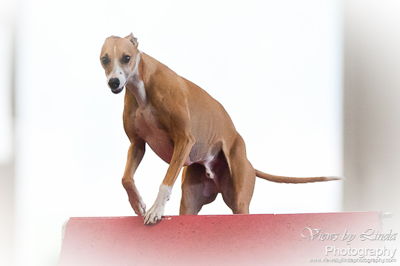

Running order

 | SATURDAY HUTTON |  | SUNDAY - LAAN
1 | Novice Standard 1 | 1 | Steeplechase 1
2 | Intermediate Standard 1 | 2 | Steeplechase 2
3 | Excellent and Master Standard 1 | 3 | Novice Standard 2
4 | PAD Novice | 4 | Intermediate Standard 2
5 | PAD Intermediate | 5 | Excellent and Master Standard 2
6 | PAD Excellent/Master | 6 | Novice Standard 3
7 | Novice JWW 1 | 7 | Intermediate Standard 3
8 | Novice JWW 2 | 8 | Excellent and Master Standard 3
9 | Intermediate JWW 1 | 9 | Novice JWW 3
10 | Intermediate JWW 2 | 10 | Intermediate JWW 3
11 | Excellent and Master JWW 1 | 11 | Excellent and Master JWW 3
12 | Excellent and Master JWW 2

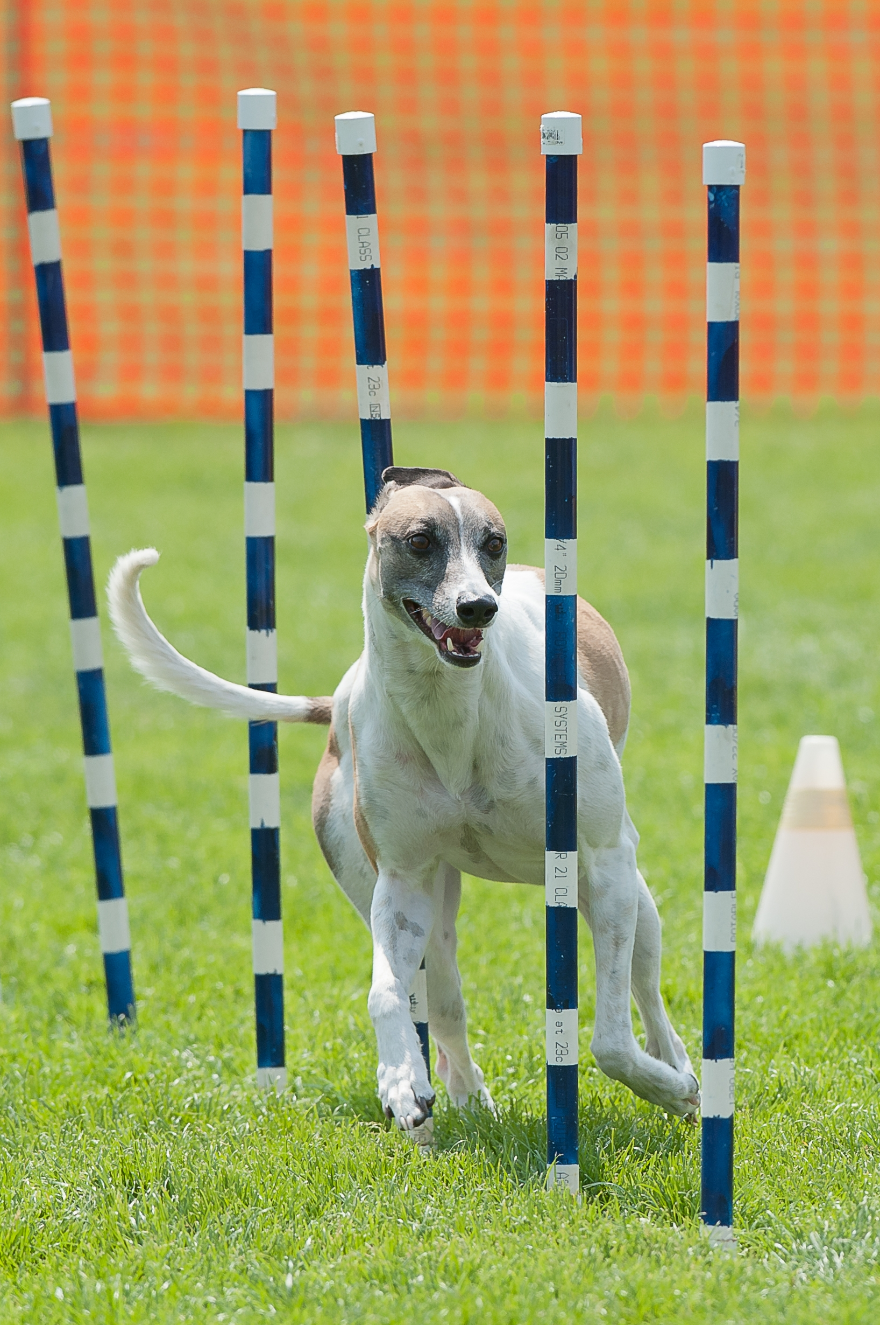
TCS Zoomerang, Fch, RE, AGX AGXJ, CGN, PCD, RCH, CBJA. CBSA, CBSLA,SR, CR, AO, AOJ.

Zoomy is rated top winning straight race champion in Canada and has received a Versatility award twice.

Some notes about the new rules in effect January 1 2014.
- PAD – new game. This strategic game involves a point gathering component and a distance element.
- STEEPLECHASE – This fast paced new game is designed to test the dog’s ability to negotiate a jumpers style course while performing the A frame and weave poles.
- Some Class Standard Course Times have changed in order to provide more time for some jump heights and levels
- A and B levels have been eliminated. The highest level is now called Master Excellent
- Position less table performance
- Continual table count
- Weave poles in all Novice Classes
- Lateral movement from Regular to Selected divisions.
- One bar jumps can be used at any level

WE NEED YOUR HELP

Agility trials can only run efficiently with volunteers; to make our trial run smoothly your participation when not running your dog will be appreciated and rewarded with WCOBC toonies, our way of rewarding those who help out. The WCOBC toonies can be used to pay for any fees associated with any Whippet Club fee. . There will be a white sheet for you to sign up for a job.

THANK YOU FOR YOUR COOPERATION

CKC AGILITY TRIAL
March 29 & 30 2014
Official Canadian Kennel Club Entry Form

Click the boxes, enter your information, print and send with payment to:
Registered Owner
Mail to:
Heather Ivanitz
970 Ackerman Court
Kelowna BC, V1X 7L2

Complete Address
Telephone Email Address
Owner’s CKC membership Handler
DOG’s Call Name BREED
DOG’S REGISTERED NAME
DOG’s Date of Birth M D Y SEX HEIGHT inches
DOG’S NUMBER TYPE: CKC Reg ERN PEN Listed ID #
Dog’s Place of Birth: Canada_ Elsewhere___ LISTED # _____
Note: Payments will be deposited on closing date. Confirmations will be sent via email prior to closing date. Schedule and catalogue will be emailed.
BREEDER:
SIRE:
DAM:
DOG’s JUMP HEIGHT (click One)
Pre-ENTRIES CLOSE SATURDAY
March 18 2014

4 8 12 16 20 24
DIVISION: Regular Selected Veteran

CLASS (click on appropriate box)
Trials 1 and 2 are Saturday – Trials 3 and 4 are Sunday.
Standard 1 - Saturday | Novice | Intermediate | Excellent 1 | Master 1
PAD - Saturday | Novice | Intermediate | Excellent 1 | Master 1
JWW 1 - Saturday | Novice | Intermediate | Excellent 1 | Master 1
JWW 2 - Saturday | Novice | Intermediate | Excellent 1 | Master 1
STEEPLECHASE 1 - Sunday |  | No levels in
STEEPLECHASE 2 - Sunday |  | steeplechase
Standard 2 - Sunday | Novice | Intermediate | Excellent 1 | Master 1
Standard 3 - Sunday | Novice | Intermediate | Excellent 1 | Master 1
JWW 3 - Sunday | Novice | Intermediate | Excellent 1 | Master 1

I CERTIFY that I am the registered owner (s) of the dog, or that I am the authorized agent of the owner (s), whose name (s) I have entered above, and accept full responsibility for all statements made in this entry. In consideration of the acceptance of the entry, I (we) agree to be bound by the rules and regulations of the Canadian Kennel Club, and by any additional rules and regulations appearing this premium list.
WCOBC coupons accepted as full or partial payment
SIGNATURE _________________
Pre -Entry Fees – see page one for break down.
Or $142.57 for package (same dog) $
This price includes the CKC recording fees of $4.80 plus GST per event.
Listing Fees = $9.18 per trial $ TOTAL enclosed $

WCOBC Waiver
Please include this signed document
with your entry form

WAIVER
- I acknowledge that I, as exhibitor, handler and patron, know and abide by the “CKC Dog Show Rules”, and that I am familiar with their content.
- I agree that the Club holding this Show has the right to refuse this entry for cause, which the Club shall deem to be sufficient.
- In consideration of the acceptance of this entry and of the holding of the Trials and of the opportunity to have the dog judged and to win ribbons or trophies.
- I agree to hold the WHIPPET CLUB OF BC, and/or the owner or the lessor of the premises Kelowna Dog Sport Centre, Central Okanagan Dog Agility Club, their members, directors, governors, officers, agents, superintendents, and show secretary of the aforementioned parties, harmless from any claim for loss or injury which may be alleged to have been caused directly or indirectly to any person or thing by the act of a dog while in or upon the show premises or grounds or near any entrance thereto, and I personally assume all responsibility and liability for any such claim, and I further agree to hold the aforementioned parties harmless from any claim for loss of a dog by disappearance, theft, death or otherwise, and from any claim for damage or injury to the dog, whether such loss, disappearance, theft damage or injury be caused or alleged to be caused by the negligence of the Club or any of the parties aforementioned, or by the negligence of any other person, or any other cause or causes.
- I hereby assume the sole responsibility for and agree to indemnify and save the aforementioned parties harmless from any and all loss and expense (including legal fees) by reason of the liability imposed by law upon any of the aforementioned parties because of bodily injuries including death at any time resulting there from, sustained by an person or persons, including myself, or on account of damage of property, arising out of or in consequence of my participation in this show, howsoever such injuries, death or damage to property may be caused and whether or not the same may have been caused and whether or not the same may have alleged to have been caused by negligence of the aforementioned parties or any of their employees or agents, or any other person.

Name _____________________________________________________________

Date____________________________ Signed_____________________________

