Official Premium List
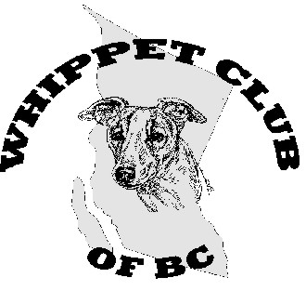

These events are held under the rules of the Canadian Kennel Club
Unbenched, unexamined show, outdoors with no cover for inclement weather
Whippet Club of BC Is hosting
1 Field Trial Conformation Show, Saturday April 25 2015 (Outdoor)150776
2 Lure Coursing Trials, Saturday & Sunday April 25 & 26 2015 150777 & 150778
FOR ALL SIGHTHOUNDS in Lavington BC
at The Icelandic Horse Farm field on Langford Rd, Lavington BC
Official Premium List
Closing date April 15,2015 for Conformation pre-entries, April 21 for lure trial entries
Event Secretary, Ivy Molloy.
970 ACKERMAN CT KELOWNA, BC, V1X 7L2 (250) 765-6247

ENTRIES AND PAYMENT
Completed entry forms may be mailed to above address or Faxed to 250 – 765 7167, or emailed to wcobc@shaw.ca. Money orders and Cheques must be Payable to WCOBC. Payment may be made through PAYPAL at wcobc@shaw.ca

Entry forms not received by the above specified dates will be considered “Late/day of” entry and the fee will be charged as such.

NO entries will be considered final without payment in full.
Tendering of a N.S.F. cheque in payment of entry fees is considered non-payment of entry fees and is an offense punishable by disciplinary action and cancellation of awards. (Chapter 13, Section 7.2, C.K.C. Dog Show Rules) All N.S.F. cheques will be assessed a $25.00 service charge.

Entry fees: Lure Field Trial and Conformation show
Pre-entry per dog per event ................................................................ $20.00
WCOBC member (entry fee per dog per event) ………………………$17.00
Each Late/Day of Trial entry (without reservation- lure only) ..............$25.00
Single/Practice/Puppy runs (see page 6 for details) … ……..………...$15.00
Listing Fee for each entry without a CKC Number............................... $ 9.32

Note: Hounds must be pre-entered to compete in the Conformation show and must complete the field trial with a qualifying score to be eligible.
The owner of a dog entered in this trial is entirely responsible for any errors in the entering of the dog, regardless of how, or by whom the entry was made.

Lure Course Classes and stakes offered:
- Open Stake - for all dogs, including Field Champions
- Mixed Stake – for multiple breeds with entries of three or less, upon owner’s agreement
- Practice/Single runs – all hounds run alone. NOT to be judged. No points awarded to winners.

Field Trial Conformation show classes:
Versatility whippet of the Year
This Lure field trial and Field Trial Conformation show,
are both qualifying events for whippets gathering credits toward the Whippet Club of BC Versatility award of 2015
Whippets winning this award receive a certificate providing free entry to all WCOBC events for one year.
For more details on this award contact Adele at wcobc@shaw.ca

- Open - for all sighthounds
- Veterans - for dogs over 7 years
- Bred by Exhibitor
- Specials Only - for Canadian Champions only.
- Altered

INSPECTION/check in AT 9 AM BOTH DAYS
Lure Course Judges: Assignments for Saturday and Sunday
Ed Molloy, 169 52061 Range Road 215 Sherwood Park AB, T8E 1B2- all breeds except greyounds
Linda Smith 0000346, 11228 100 Ave NW, Edmonton AB, T5K 0H9 – Afghan, Basenji, Borzoi, GH, Italian GH, Saluki, Whippet, IW
Adele McNiven, 970 Ackerman Court, Kelowna, BC, V1X 7L2– Deerhound, GH, Ibizan, Pharaoh
Conformation Judge:.
Tempest A. Deptuch 0006289 709 Stone Rd Louis Creek BC, V0E 2E0 - All sighthounds
Russel Fletcher (0006290) Box 18 Louis Creek BC, V0E 2E0 - Italian Greyhounds

Running order will be alphabetical except for Greyhounds and Ibizan Hounds

Field trial Conformation show
Saturday
at the conclusion of the Lure trial
PRE ENTRIES Close April 15, 2015

Whippet Club of BC Club Officers:
President: Adele McNiven
Vice President: Fiona Hart
Secretary: Carole Adley
Treasurer: Heather Ivanitz

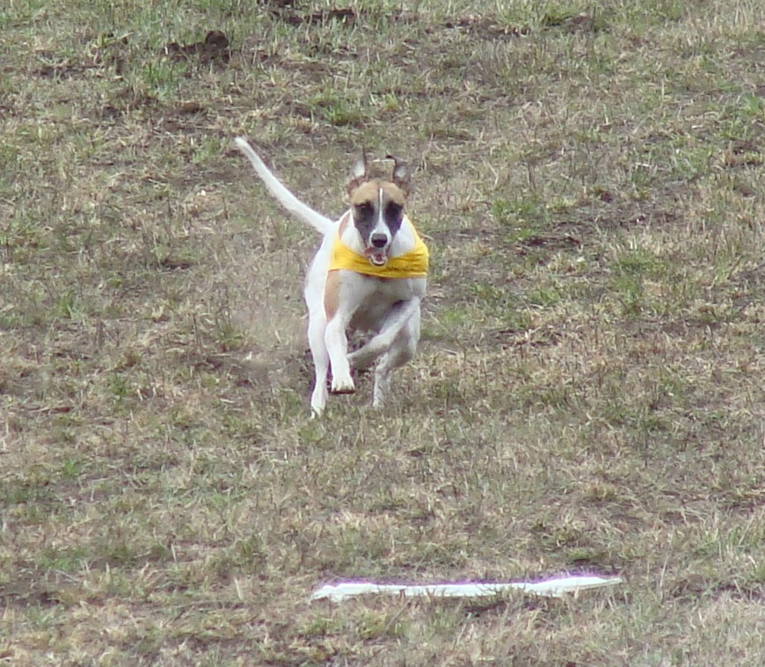

Show/Field Trial Committee: Members of the WCOBC
Trial Chair: Heather Ivanitz
Trial Secretary: Ivy Molloy.
Entries to 970 Ackerman Court, Kelowna BC, V1X 7L2
Lure Operator: Ray Fessenden
Hunts master: Fiona Hart
Field Clerks: Heather Ivanitz and Carole Adley

Canadian Kennel Club:
B.C. Director Interior Zone: Russel A Fletcher (0006290) Box 18 Louis Creek BC V0E 2E0
CKC Coursing Director for the Interior of BC: Adele McNiven .
CKC Offices: 200 Ronson Drive, Suite 400, Etobicoke, ON.M9W 5Z9Phone: (416) 675-5511
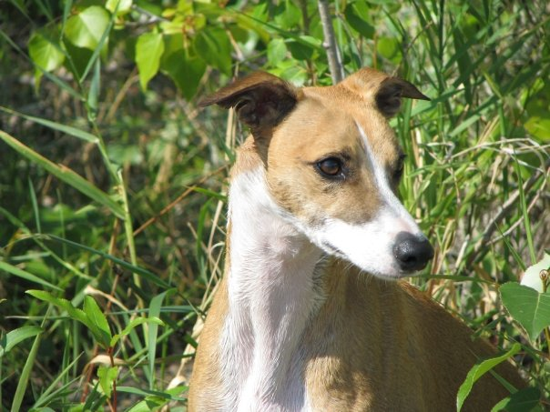

Exhibitor Information for lure trial:
- Stakes will be split if the entry is 24 or more hounds at the time of Roll Call.
- Dogs not present at Roll Call will be scratched and entry fee not refunded
- Hounds will be run twice, in braces or trios (except single dog entries) unless dismissed, excused or disqualified.
- Bitches in season and lame hounds will be excused and their entry fee refunded, provided notice is given prior to or during roll call.
- All handlers must use a slip lead when releasing their hounds.
- Muzzles and catch collars may be used at the handlers' discretion. Leg wrappings must be a neutral color to comply with CKC rules.
- There will be a $10 fine for dogs found loose on coursing field after roll call and before the end of the trial.
- Coursing entries received after the closing date will be charged the “late/day of trial” fee;
- Any exhibitor not cleaning up after their dog will be assessed a fine of $10.00 – strictly enforced!
- It shall be the duty and obligation of the trial-giving club to see that a judge, club official,
Volunteer, or any participant at an event held under these rules is not subject to indignities of
any kind. The Field Trial Committee Chair shall promptly report to the CKC any infringement
of this regulation and the Discipline Committee shall have the authority to take such action as
it deems fit on receipt of a report indicating that this has occurred.
- Anyone exhibiting unsportsmanlike conduct will be asked to leave the trial site.
- Dry Camping is available on site. However, the entrance to the field is rather steep and restrictive to some large RVs.

Equipment:
Battery powered drag line, with white plastic streamers as the lure.

Eligibility to enter these trials
Lure Field Trial:
Open to any Afghan, Basenji, Borzoi, Greyhound, Ibizan Hound, Pharaoh Hound, Saluki, Scottish
Deerhound, Whippet, Irish Wolfhound , Italian Greyhound who is one year or older on the day of the trial.
All entrants must be registered or eligible for registration with the CKC.
Altered and neutered dogs may compete.
Dogs presently disqualified under CKC, ASFA, or AKC rules are not eligible.
Hounds must pre-qualify before entering their first trial in Canada. If applicable, please provide proper certification with your entry. See below

Conformation show:
Open to any Afghan, Basenji, Borzoi, Greyhound, Ibizan Hound, Pharaoh Hound, Saluki, Scottish
Deerhound, Whippet, Irish Wolfhound, Italian Greyhound that has earned a qualifying score in the preceding lure course, except those with breed standard disqualifications. A hound excused, dismissed, disqualified, scratched, or not scored in the lure trial is not eligible to compete in the conformation show.
All entrants must be registered or eligible for registration with the CKC.
Altered and neutered dogs may compete in the ALTERED class only.

Event Registration Numbers: All dogs that are foreign born and foreign owned and enter Canada for the sole purpose of entering CKC events do not require a CKC registration number but will require an Event Registration Number (ERN).
To obtain an ERN simply mail a copy of the dog's registration certificate with a cheque money order or VISA/Mastercard number (expiry date, cardholder's name and signature) in the amount of $55.00 + GST payable to the Canadian Kennel Club. This Event Registration Number MUST be applied for with 30 days of the first day of entering a CKC Event. Please forward your request to The Canadian Kennel Club, Shows and Trials Division 100-89 Skyway Avenue, Etobicoke, Ontario M9W 6R4 Fax (416-675-6506

Attention Foreign Exhibitors
Entry Payment: Please note that fees are due and payable in Canadian dollars.
***Border crossing – A rabies certificate is required to bring a dog into Canada. Government regulations require a certificate and it must be dated at least 30 days prior to entry into Canada.

Please note that fees are due and payable in Canadian dollars. Due to consistently fluctuation currency rates discounted cheques will not be accepted. We urge that bank drafts or money orders in Canadian Funds be purchased.

Attention all Canadians – information regarding titles
The following is quoted from the CKC website
“The following non-member participation fee now applies and is retroactive to January 1,2011.
The non-member participation fee applies to all Canadian residents who participate in a CKC event but are not CKC members and a participating non-member can chose to purchase a CKC membership or pay the non-member fee. This only applies to dogs wholly owned by non members and is not applicable to CKC members or dogs co-owned with a CKC member. In order for the CKC to efficiently manage recording and tracking points, it's important that non-members select one of the two options within 30 days of notification or, unfortunately, we will be forced to cancel any awards and titles

Non-Member Participation Fee
24-12-3. Non-member participation fee
a) An annual non-member participation fee for awards and titles will be charged to a Canadian non-member of CKC. The fee will match the ERN fee.
b) In order to protect the awards/titles earned, the non-member will have a choice either to become a CKC member or to pay the non-member participation fee. Failure to comply within 30 days of notification will cause all awards and titles to be canceled.
c) The Premium List must carry a note stating that “ these fees apply only to dogs wholly owned by non-CKC members and are not applicable to CKC members.”

Course plans:
Not to scale. Course may be altered to suit weather/filed conditions. Field is a rolling horse pasture.
A drag line with plastic streamers will pulled by a gas powered lure machine.
Saturday 690 yds | Sunday 728 yds
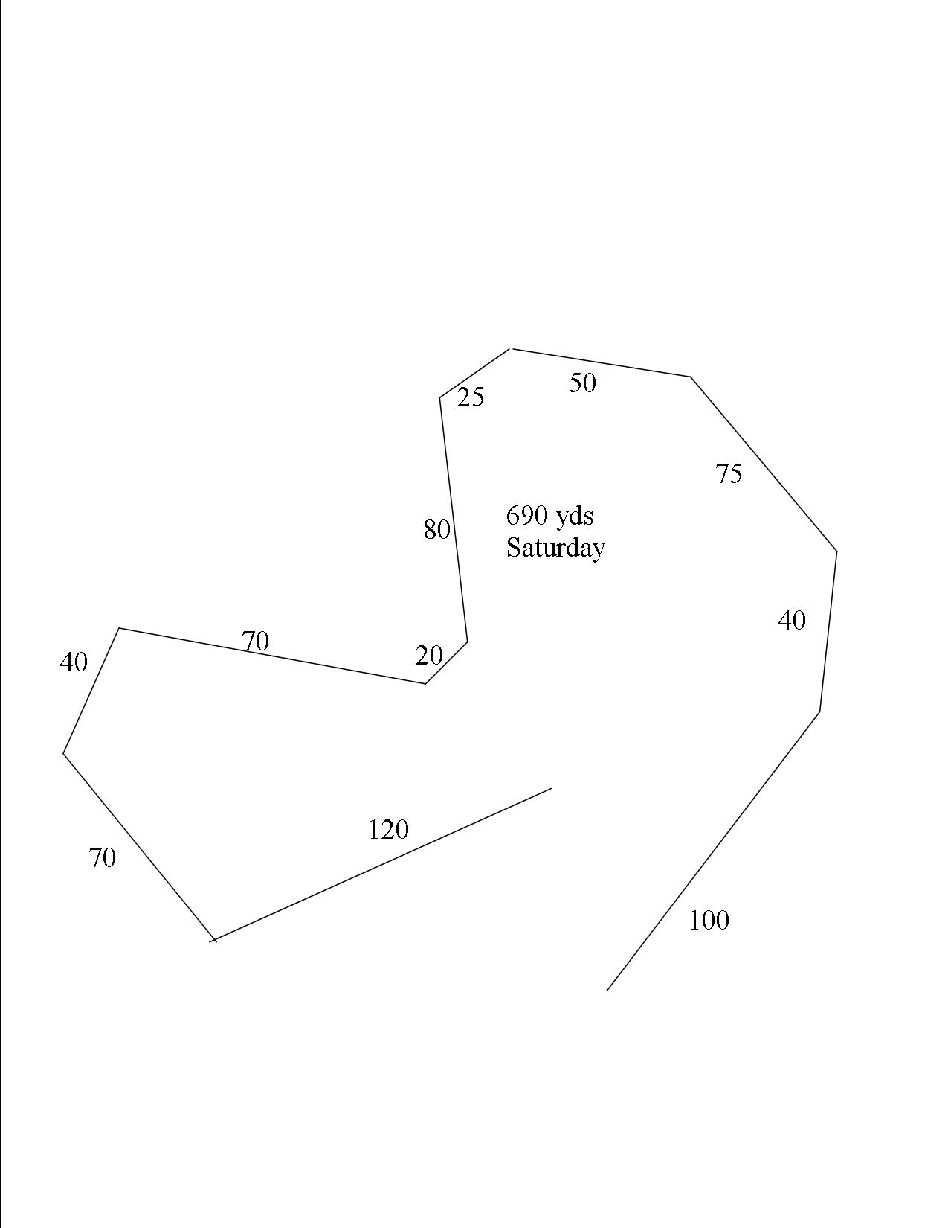 | 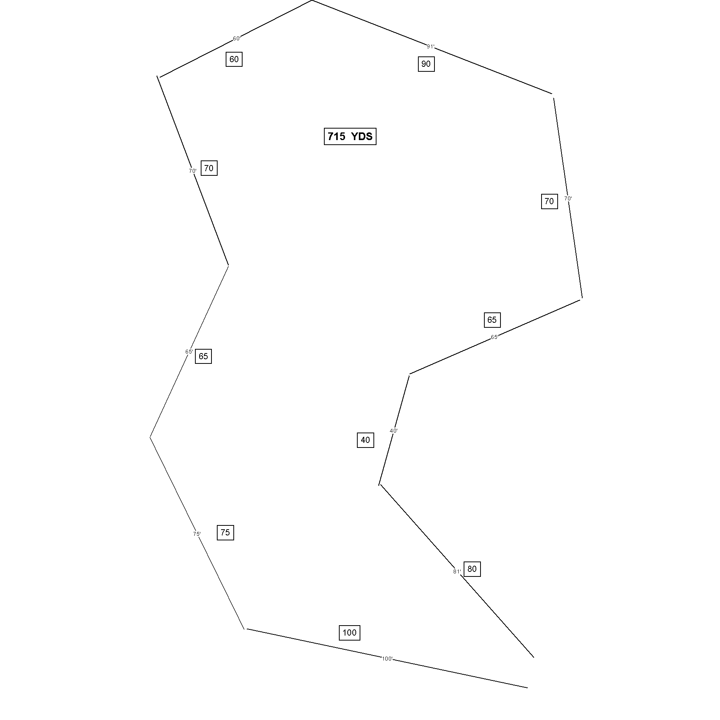 | NOTE:  Courses may be changed due to field conditions

Back by popular demand is the Berlin Friend and Family Jam and Jelly sale!
The funds raised from the sale of these tasty products go towards paying our many expenses incurred in hosting whippet and sighthound events.

Return of empty jars is much appreciated.

Directions to the coursing and conformation site
About 25 minutes from Downtown Vernon BC
Follow WCOBC lure signs from the corner of Hwy 6 to the field.

From Vernon take Hwy 6 East (towards Lumby/Nelson)
- Drive 15 km, (just after an Esso station on the left), turn right/south into Park Lane
- stay on Park Lane for 1.4 km until it ends (after railroad crossings) in a T-intersection with Learmouth Rd
- turn left onto Learmouth and follow it up the winding hill for 1.7 km until it ends in another T-intersection with Reid Rd.
- turn left and follow Reid Rd uphill for 1.1 km it turns into Bluenose Rd at a sharp right corner,
- stay on Bluenose Rd
- just after Whitevale Rd (which turns off to the left), you will see Langford Rd (which is a gravel road ) to your right - turn onto it and after 200 meters the field entrance is to your right.

Address is #5290 Reid Rd , except we enter from the back of the property.
This is a horse pasture.

There are accommodations in Lumby and Vernon.
We have heard that these Vernon Hotels accept dogs:

Tiki Village Motor Inn 2408 34th Street, (250) 503-5566
Blue Stream Motel (prefers small dogs) 4202 32 Street (250) 545-2221
Travel Lodge 3000 28th Ave (250) 545-2161
Best Western Villager 5121 26th Street (250) 549-2224
Hillside Plaza Inn 4100 32nd Ave (250) 549 1211
Holiday Inn Express 4716 34th Street (250) 550 7777

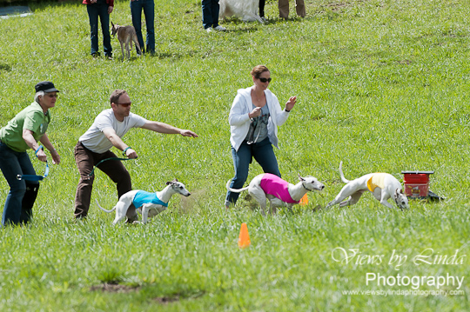

NOTES to COURSERS
- Camping is permitted on the grounds for self contained units only.
- Please notify Adele at wcobc@shaw.ca if you would like to camp.
- No flush toilets on site. A porta potty will be available.
- All dogs must be under control at all times.

- Please be prepared with your bag lunch as there are no restaurants close by, however there is a gas station and some eats at the corner of Hwy 6 and School Road about 10 minutes away.
- Our Field trial conformation show will follow the Lure trial on Saturday.
The exact location will be announced.

- Cell phone on trial site 250 862 0683

Please come and have fun at our trial.
We have had challenges in finding a suitable field and we appreciate the Icelandic Horse Farm for generously allowing us to run our dogs on their pasture.
We know that we will get cooperation from everyone using the field and that we will be leaving the site as pristine as it was upon our arrival.
Thank you

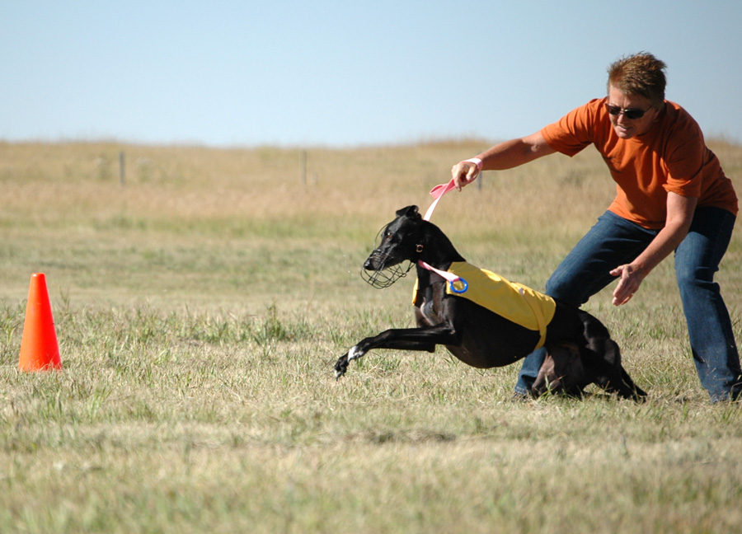

UNOFFICIAL EVENTS
LIMITED ENTRY -- by PRIOR ARRANGEMENT ONLY!
Contact wcobc@shaw.ca to reserve a spot.
Include dog name, dog breed, and handler name

- FRIDAY - Certification runs to be held late afternoon/early evening

- SUNDAY - Straight line lure practice for puppies and dogs of all breeds, mixed breeds, and unrecognized breeds.
TWO runs per dog
During the Lure trial lunch break

Unofficial events $15.00 per dog

OFFICE USE |  |  | OFFICIAL CANADIAN KENNEL CLUB ENTRY FORM  LURE FIELD TRIAL  April 25 and 26 2015  FIELD TRIAL CONFORMATION  Saturday April 25, 2015  Whippet Club of BC
Make cheques payable to WCOBC and mail to: 970 Ackerman Court Kelowna BC, V1X 7L2 FAXED, emailed entries accepted that are followed up with Paypal payment to wcobc@shaw.ca
Sorry, No or credit card ENTRIES. Payment must accompany entry for it to be considered complete.
This is a Computer ready form.
Click and enter your information, print, and sign. Or Print and complete Clearly by hand
ENTER IN THE FOLLOWING CLASSES: One entry form per hound
Saturday CONFORMATION: Pre entries only MALE FEMALE
Open, Veteran, Bred by Exhibitor, Specials only, Altered
LURE TRIAL SAT SUN
If this is the hound’s first trial in Canada a Hound Certification Form must be attached with dog info complete
Pre-entry - per dog per event/day all events. SAT $20.00 SUN $20.00 = $
WCOBC member pre entry (per dog per day) SAT $17.00 SUN $ 17.00 = $
Each Late/Day of Trial entry (without reservation- lure only) $25.00
Listing Fee for each entry without a CKC Number………….... = $ 9.32
TOTAL ENCLOSED $
BREED: |  |  |  |  | Call Name: |  |  | MALE  FEMALE
Registered name of Hound:
This hound is eligible for the following High Score recognition: Ch., FCh., FchX
Oval track title Straight track title Obedience title Rally title Agility title Veteran.
FTE (First time entered)
Hound Registration: CKC REG. # |  |  |  | Check one and enter number  Other registry # Type of #
DATE OF BIRTH  / /  Day Month Year |  | PLACE OF BIRTH  Canada Elsewhere |  |  |  | Please separate my hounds
REG’D OWNER(S):
OWNER’S ADDRESS:
E-MAIL ADDRESS:
PHONE #: Owner’s CKC membership #
BREEDER(S):
SIRE:

DAM:
NAME OF OWNER’S AGENT
AGENT’S ADDRESS:
email:
Email confirmation TO: owner Agent
I CERTIFY that I am the registered owner(s) of the dog or that I am the authorized agent of the owner(s) whose name(s) I have entered above and accept full responsibility for all statements made in this entry. In consideration of the acceptance of this entry, I (we) agree to be bound by the rules and regulations of the Canadian Kennel Club and by any additional rules and regulations appearing in the premium list.

_____________________________________________________________________________________________________

SIGNATURE OF OWNER OR AGENT
WCOBC Waiver
Please include this signed document
with your entry form

WAIVER
- I acknowledge that I, as exhibitor, handler and patron, know and abide by the “CKC Dog Show Rules”, and that I am familiar with their content.
- I agree that the Club holding this Show/Trial has the right to refuse this entry for cause, which the Club shall deem to be sufficient.
- In consideration of the acceptance of this entry and of the holding of the Trials and of the opportunity to have the dog judged and to win ribbons or trophies, I agree to hold the WHIPPET CLUB OF BC , their members, directors, governors, officers, agents, superintendents, show secretary and/or the owner or agent of the premises, and any employees of the aforementioned parties, harmless from any claim for loss or injury which may be alleged to have been caused directly or indirectly to any person or thing by the act of a dog while in or upon the show/trial premises or grounds or near any entrance thereto.
- I personally assume all responsibility and liability and I further agree to hold the aforementioned parties harmless from any claim for loss of a dog by disappearance, theft, death or otherwise, and from any claim for damage or injury to the dog, whether such loss, disappearance, theft damage or injury be caused or alleged to be caused by the negligence of the Club or any of the parties aforementioned, or by the negligence of any other person, or any other cause or causes.
- I hereby assume the sole responsibility for and agree to indemnify and save the aforementioned parties harmless from any and all loss and expense (including legal fees) by reason of the liability imposed by law upon any of the aforementioned parties because of bodily injuries including death at any time resulting there from, sustained by an person or persons, including myself, or on account of damage of property, arising out of or in consequence of my participation in this show, howsoever such injuries, death or damage to property may be caused and whether or not the same may have been caused and whether or not the same may have alleged to have been caused by negligence of the aforementioned parties or any of their employees or agents, or any other person.

Date _____________________Signed______________________________________

Print name: __________________________________________________________

First time entered hounds:
Effective July 1998, hounds entering their first trial in Canada must be tested with another dog, not a kennel mate, preferably of the same breed, and certified running clean by a licensed judge. The CKC Hound Certification form (included with this premium list) must be completed and submitted with their entry at the hound's first trial. Hounds with the following are exempt: ASFA F.Ch. or LCM, AKC F.Ch.,, but are still required to submit the Hound Certification form with their name and exempt title(s) circled.

HOUND WAIVER FORM

Registered Owner:

Registered Name of Hound
Call name of Hound:
CKC Registration Number: Breed:
Waiver of Requirement: This requirement will be waived for a hound that has earned a lure coursing title from another recognized organization if such title required competition, and if a waiver for such title has been approved by the Canadian Kennel Club. If a hound qualifies for a waiver, complete the top half of this form and attach it to your entry form.
- All hounds must be a minimum of 12 months of age prior to being certified.
- All hounds must run a normal course of 600 yards in order to be certified.

AKC Titles: (Circle One) FC SC DC ASFA Titles: (Circle One) F.CH. LCM

Signature of Owner or Agent: _____________________________________________
Date:

HOUND CERTIFICATION FORM

I hereby certify that on (date) ____________________ the above named hound completed a lure course of at least 600 yards running with another hound of the same breed (or another breed with similar running style). During the course, the above named hound showed no inclination to interfere with the other hound. I further certify that I am a licensed judge for the breed certified.

Name of Licensed Judge: _____________________________________________________

Signature of Licensed Judge: ___________________________________________________
I hereby certify that the hound run in the certification course is the hound identified above and that the information on this form is correct.

This certification form must be attached to the entry form the first time this hound is entered in a lure trial. Any hound entered in Open or Veteran Stake which has not been certified shall be declared ineligible by the Records Coordinator and shall forfeit any points or placements earned.

