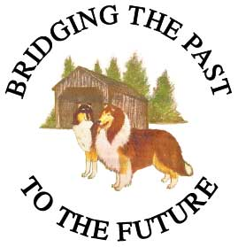**Collie Club of Canada**

**2018 National Specialty Banquet**

**Please email completed form to Krista Allison at** [**alliskri@nbed.nb.ca**](mailto:alliskri@nbed.nb.ca) **or fax at 1-506-869-6105. Money order, send to 230 Bulman Drive, Moncton, NB, EIG5P1 or e-transfers need to accompany registration for banquet. If you need assistance, please call Krista at (506) 874-9748. Deadline is October 31, 2018.**

**Location:** Days Inn Banquet room (2515Mountain Rd., Moncton)

**Date:** November 17, 2018

**Cost:** $45.00 per person

**Cocktails:** 6:00PM (Cash Bar)

Please choose from the following selections by placing an X in the space provided.

**NAME(S):**

**Appetizers:**

Fresh Crisp Garden Salad with Golden Italian Dressing

OR

Soup – Cream of Wild Mushroom or Carrot & Ginger

**Main Entrée:**

Medallions of Pork

Seared medallions glazed with a unique sweet balsamic sauce,

served with a vegetable medley and garlic whipped potatoes.

OR

Classic Roast Beef Dinner

Canadian AAA Beef that is slow roasted to perfection, complimented

with a red wine sauce and garnished with a horseradish tart. This is

served with a vegetable medley and whipped potatoes.

**Dessert:**

Creamy Style New York Cheese Cake topped with a Wild Berry Coulis

OR

Black Forest Cake

* Please indicate if you have any dietary restrictions, allergies or sensitivities and require an alternate menu