 LABRADOR RETRIEVER CLUB OF ALBERTA

**OFFICIAL PREMIUM LIST**

**WORKING CERTIFICATE TESTS**

**@**

## Wabamun, ALBERTA

## Monday, 2 July 2018

**FEATURING:** Working Certificate Test, Working Certificate Intermediate Test, and

Working Certificate Excellent Test

Open to All Retrievers, Irish Water Spaniels, Poodles, Airedale Terriers, and Barbets

Permission has been granted by the Canadian Kennel Club for the holding of these events under the rules of the Canadian Kennel Club.

**ENTRIES CLOSE 6:00 p.m., 26 June, 2018**

Make all cheques payable to LABRADOR RETRIEVER CLUB OF ALBERTA. No entries with cheques dated after the closing date will be accepted. Mail, Courier, or drop cheques and completed entries to:

|  |  |
| --- | --- |
| Anne Nette, WC Test Secretary  90 Pembroke Crescent  St. Albert, AB T8N 4S5 | Phone: (780) 460-1362  e-mail: knette@interbaun.com |

Please allow adequate time for mail delivery.

**Tests will start promptly at 8:30 am** with the WC land tests, followed immediately by the land tests for WCI and WCX. Water tests will be held after all land tests have been completed. Handlers are requested to check in with the Test Secretary, at the shelter beside the parking lot, no later than 8:15am.

# LABRADOR RETRIEVER CLUB OF ALBERTA

### Officers and Test Committee

President Christine Enns

Vice President Sandi Bell

Secretary Shannon Morin

Treasurer Cindy Drobot

WC Test Chair Ken Nette

WC Test Secretary Anne Nette

WC Test Committee Ken Nette, Anne Nette, Brian Proctor, May-Britt Wiegel, Christine Grenier

## CANADIAN KENNEL CLUB

400, 200 Ronson Drive., Etobicoke, ON M9W 5Z9

## CKC ZONE DIRECTOR FOR ALBERTA

Sharon Derrick

60 Riverview Close SE, Calgary, AB, T2C 4C4

## CKC WC REPRESENTATIVE FOR ALBERTA

Lionel Whittaker

4529 Mead Court NW, Edmonton, AB, T6R 0T1

## JUDGES

Lisa Williams 44 Sunmeadows Crt SE WC,WCI,WCX

Calgary, Alberta

T7Y 0A6

Bill Marshall 12912-62 Ave, NW WC,WCI,WCX

Edmonton, Alberta

T6H 1N8

## ENTRY FEES

## Working Certificate $35.00

## Working Certificate Intermediate $40.00

## Working Certificate Excellent $45.00

## Listing Fee* $10.00

## *Required for any dog without an individual CKC registration number or ERN Number

## ALL QUALIFYING DOGS WILL RECEIVE A ROSETTE

### NOTICE TO EXHIBITORS

Any person participating in any capacity at a Hunt Test or Working Certificate Test held under the CKC rules and regulations shall not be subjected to any indignity of any kind during the progress of the tests and it shall be the duty and obligation of the Labrador Retriever Club of Alberta to see that this rule is effectively carried out. On report to the Labrador Retriever Club of Alberta of an alleged indignity of any kind the Test Chairman will report the infringement to the CKC and the Test Committee shall forthwith conduct an investigation and shall have the power to take action as it deems fit on receipt of a report indicating that this rule has been violated.

## GENERAL INFORMATION

1. Working Certificate Test Rules and Regulations Books are available from the Canadian Kennel Club, Suite 400, 200 Ronson Drive., Etobicoke, ON M9W 5Z9
2. Entries must be typewritten or clearly printed. Owners are responsible for errors on entry forms. The Labrador Retriever Club of Alberta does not assume any responsibility for incorrect information or errors due to illegibility of information on any entry form. Make cheques payable to the Labrador Retriever Club of Alberta.
3. A separate Entry Form for each dog in each test is required (official CKC Entry Form).
4. Entry fees **will not** be refunded after **6:00 P.M., Monday, 26 June, 2018**. In the event that a dog is absent, disqualified, excused by a judge or barred from competition by action of the Test Committee or the Canadian Kennel Club, or because it has been entered incorrectly, or if it is impossible to open or complete the test, no refund of entry will be made.
5. In the event of a mail strike, please courier or hand deliver entries to the Test Secretary prior to the closing date.
6. No POST-DATED cheques will be accepted.
7. Post entries will not be accepted.
8. Running order will be determined by random selection. Running order will be available after 6:00 P.M. Friday, 29 June, 2018.
9. Bitches in season shall not be eligible for entry.
10. Ducks will be used in all tests.
11. For the WC, WCI and WCX Tests, all tests will be run at the same location and all land retrieves for all tests will be run before water tests.
12. All throwers, Judges and competitors should wear dark or camouflaged clothing.
13. Any dog not appearing within 15 minutes of being called to the line by the Marshall may be disqualified.
14. Entry and listing fees paid for any dog withdrawn because of injury, illness, estrus, or death shall be refunded in full. An appropriate veterinary certificate must be given to the Test Secretary BEFORE the start of the test to qualify for a refund. All other refunds must be requested in writing within 14 days of the event, explaining the reason for the scratch. Scratches will be refunded at the discretion of the Test Committee, all but a fee of $15.00.
15. Effective Jan.1992, all dogs that are foreign born and foreign owned and enter Canada for the sole purpose of entering CKC events no longer require a CKC registration number but will require an event registration number (ERN). Each dog must have its own number. To obtain an ERN number from CKC, send them a photocopy of the dog's foreign registration certificate with cheque or VISA/Mastercard number. Provide your complete address for return of ERN number. Cost $62.40 (plus GST). ERN numbers must be applied for within 30 DAYS of the FIRST day of entering a CKC event.
16. The Labrador Retriever Club of Alberta and its members will use due care and diligence for the welfare of dogs and exhibitors, BUT will not be responsible for, nor assume any liability in the event of an accident, injury or other misfortune to either dogs, exhibitors or patrons.
17. Electric Collars (either dummy or live) as well as prong or pinch type collars shall not be worn by any dog on the test grounds at any time during the event.
18. There shall be no training of dogs on the test grounds, except for single training bumpers, which are thrown by hand by the trainer, within 24 hours of the commencement of the event or anytime during the event.

## ATTENTION: CANADIAN EXHIBITORS

***CKC Non-Member Participation Fee***

a) An annual non-member participation fee for awards and titles will be charged to a Canadian non-member of CKC. **The fee is $62.40 + GST.**

b) In order to protect the awards/titles earned, the non-member will have a choice either to become a CKC member or to pay the non-member participation fee. Failure to comply within 30 days of notification will cause all awards and titles to be cancelled.

c) "these fees apply only to dogs wholly owned by Canadian resident non-CKC members and are not applicable to CKC members"

*Please note that the CKC Membership Application and the Non-Member Participation Fee forms are available on the website, http://www.ckc.ca under CKC Services and then Forms On-line. If submitting a Membership Application, please ensure that you also complete the Non-Member Participation Fee form so that we are aware of the dogs involved.

**This fee does not have to be paid before entering this event.**

RELEASE AND INDEMNIFICATION

By entering this Test each participant agrees to assume all risks and hazards incidental to participation in the Test and agrees to release and to save harmless and indemnify the owner(s) and/or leasee(s) of any property upon which the Test may be held together with their officers, agents, employees and representatives from all claims, actions, costs, expenses and demands in respect to death, injury, loss or damage to the person or property of the participant howsoever caused, arising out of or in connection with the participants use or entry upon the property. It is understood that this agreement is binding upon the participants, his or her heirs, executors and assigns.

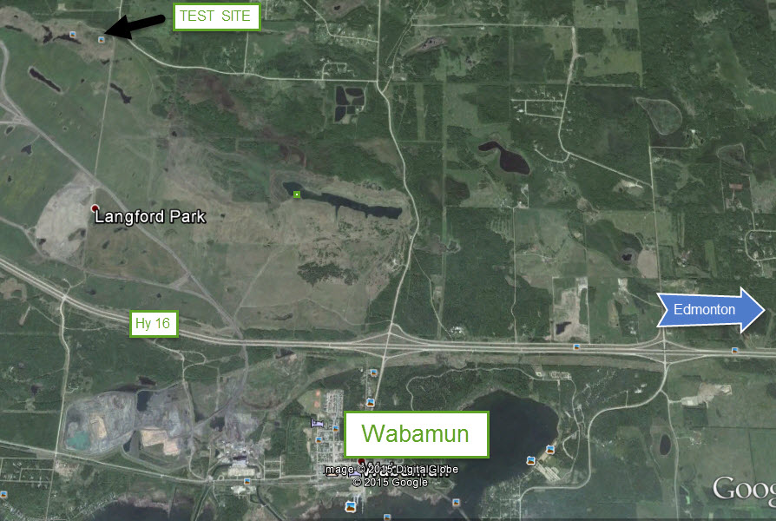

|  |  |  |  |
| --- | --- | --- | --- |
| **OFFICIAL CANADIAN KENNEL CLUB ENTRY FORM**  Labrador Retriever Club of Alberta  **Closing: Monday, 26 June 2018** | | | |
| Enter Classes/Dates in Fields Below | | | |
| |  | | --- | | WC/WCI/WCX | | Monday 3 July, 2018 | | WC $35; WCI $40; WCX $45 | | |   *Please Type or Print Clearly. Use only one entry form per dog per entry*  **ENCLOSED**  **FOR ENTRY FEES**  **FOR LISTING FEES** | | | |
|  | | | |
| Enter in the following class: *(refer to Premium List)* | | | |
| **Breed** | Variety | | Sex |
| **Reg’d Name of Dog:**  **(CKC - RECOGNIZED**  **TITLES ONLY)** | | | |
| **CHECK ONE AND ENTER NUMBER HERE**  **CKC Reg.No.**  **CKC ERN No.**  **CKC Misc.Cert.No.** | | **Date of Birth**  **Month____ Day___ Year_____**  **Place of Birth**  **Canada Elsewhere** | |
| **Breeder(s)** | | | |
| **Sire** | | | |
| **Dam** | | | |
| **Reg’d Owner(s)** | | | |
| **Owners Address** | | | |
| **City Prov/State Postal/Zip Code** | | | |
| **Name of Owner’s Agent (if any)** | | | |
| **Agent’s Address** | | | |
| **City Prov/State Postal/Zip Code** | | | |
|  | | | |
|  | | | |
| ***I accept full responsibility for all statements made on this entry. I hereby certify that I understand the CKC rules and regulations, conditions and provisions in the Premium List for this show and I agree to be bound by the same***  **______________________________________________ (______)_______________**  **Signature of Owner or Agent Telephone Number**  **_________________________________________________**  **e-mail** | | | |

|  |  |  |  |
| --- | --- | --- | --- |
| **OFFICIAL CANADIAN KENNEL CLUB ENTRY FORM**  Labrador Retriever Club of Alberta  **Closing: Monday, 26 June, 2018** | | | |
| Enter Classes/Dates in Fields Below   |  | | --- | | WC/WCI/WCX  Monday 3 July, 2018 | | | | |
| |  | | --- | | WC $35; WCI $40; WCX $45 |   *Please Type or Print Clearly. Use only one entry form per dog per entry*  **ENCLOSED**  **FOR ENTRY FEES**  **FOR LISTING FEES** | | | |
|  | | | |
|  | | | |
| Enter in the following class: *(refer to Premium List)* | | | |
| **Breed** | Variety | | Sex |
| **Reg’d Name of Dog:**  **(CKC - RECOGNIZED**  **TITLES ONLY)** | | | |
| **CHECK ONE AND ENTER NUMBER HERE**  **CKC Reg.No.**  **CKC ERN No.**  **CKC Misc.Cert.No.** | | **Date of Birth**  **Month____ Day___ Year_____**  **Place of Birth**  **Canada Elsewhere** | |
| **Breeder(s)** | | | |
| **Sire** | | | |
| **Dam** | | | |
| **Reg’d Owner(s)** | | | |
| **Owners Address** | | | |
| **City Prov/State Postal/Zip Code** | | | |
| **Name of Owner’s Agent (if any)** | | | |
| **Agent’s Address** | | | |
| **City Prov/State Postal/Zip Code** | | | |
|  | | | |
|  | | | |
| ***I accept full responsibility for all statements made on this entry. I hereby certify that I understand the CKC rules and regulations, conditions and provisions in the Premium List for this show and I agree to be bound by the same***  **______________________________________________ (______)_______________**  **Signature of Owner or Agent Telephone Number**  **_________________________________________________**  **e-mail** | | | |